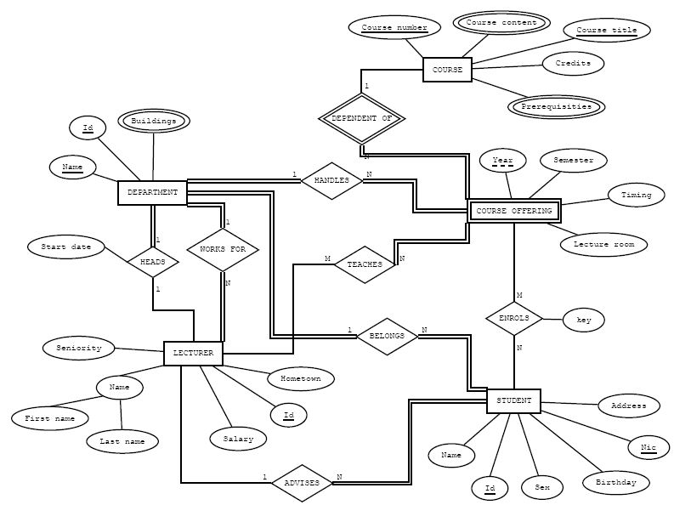

Assumptions

-One lecturer can be head of only one department at a time

-Department has only one head

-A department definitely has a head

-A department has at least one lecturer and a lectuter definitely belong to one department only

-A course offering can be taught by several lecturers

-A course offering definitely has a lecturer

-A student can have only one advisor and definitely has an advisor

-A lecturer can have no students to advise

-Lecturers ID is unique

-A student definitely has one department

-A department has at least one student

-There can be courses where no students are enrolled and there can be students who are not enrolled

to any course

-Course offerings are weak entities that depend on the entity course

-Department handles at least one course

-A single course cannot be handled by multiple departments and a course offered should definitely

has a department

-There can be several offerings of the same course but only one offering per year. So year can be

used as a weak key